- Write a Terraform script to provision an EC2 instance.
Step 1: Open VS code
aws --version
If installed, configure it:
aws configure
It asks:
AWS Access Key ID:
AWS Secret Access Key:
Default region name: ap-south-1
Default output format: json
Step 2: Test AWS connection
aws sts get-caller-identity
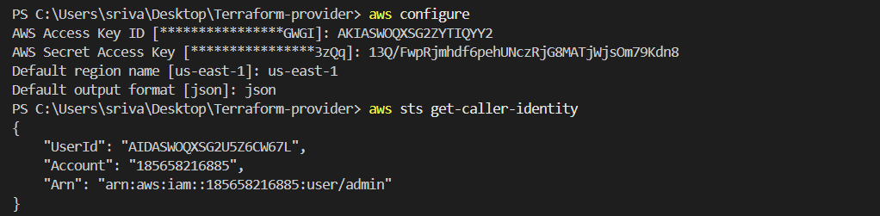

1.Create a Terraform folder
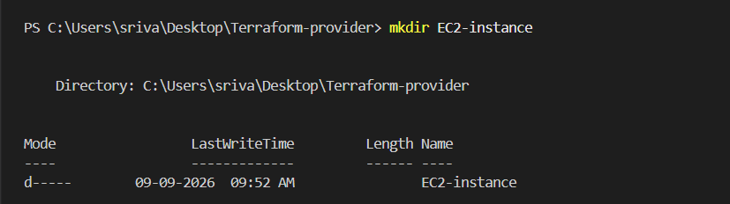

2. Create main.tf
notepad main.tf
configure the main.tf file.

terraform {
required_providers {
aws = {
source = "hashicorp/aws"
version = "~> 6.0"
}
}
}

provider "aws" {
region = "us-east-1"
}

resource "aws_instance" "web" {
ami = "ami-081b0a6eac00b4f53"
instance_type = "t3.micro"
key_name = "linux-key"

tags = {
Name = "Terraform-EC2"
}
}

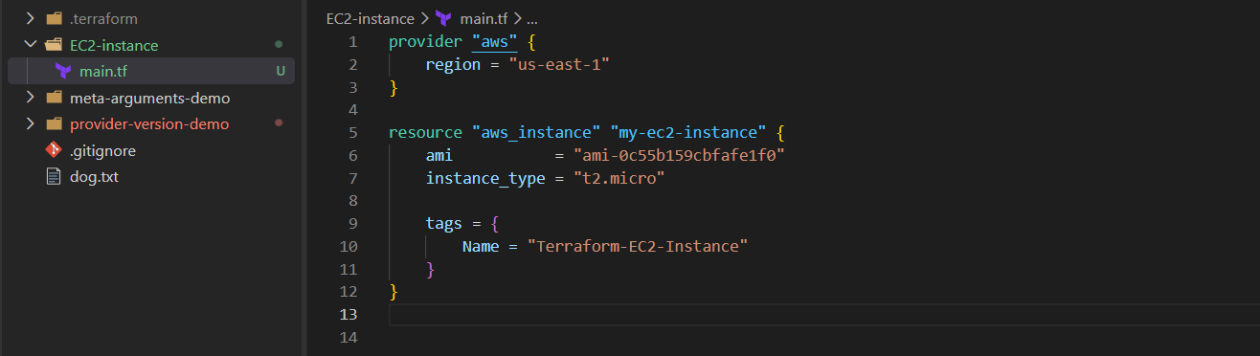

3. Initialize Terraform
terraform init
This downloads the AWS provider. 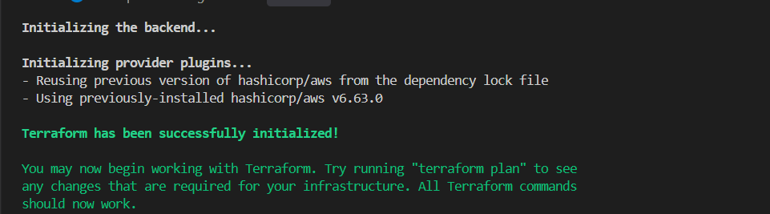

4. Check the Terraform code
terraform validate
Expected:
Success! The configuration is valid.

5. See what Terraform will create
terraform plan
You should see:
Plan: 1 to add, 0 to change, 0 to destroy. 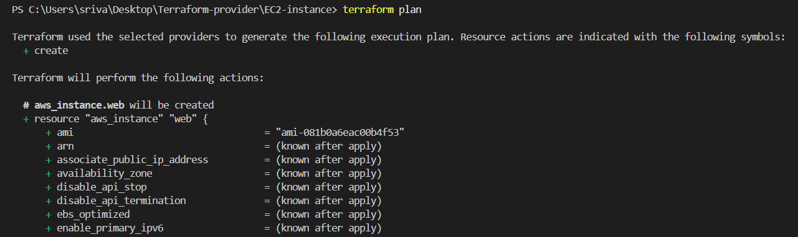

6. Create the EC2
terraform apply
Terraform asks:
Do you want to perform these actions?
Enter a value:
Enter:
yes
Terraform creates the EC2 instance. 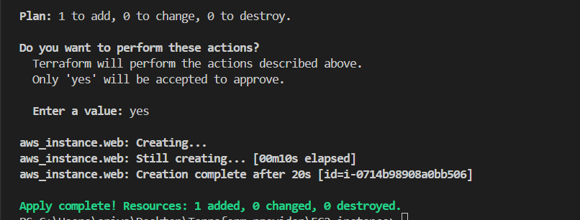

7. Check AWS Console
Go to:
AWS Console → EC2 → Instances
You should see:
Name: Terraform-EC2
Instance type: t2.micro
Region: us-east-1
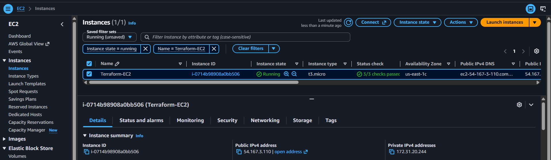

8. Destroy when finished
To avoid unnecessary AWS charges:
terraform destroy
Enter:
Yes 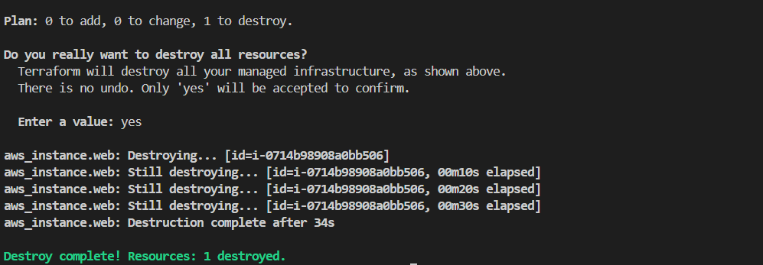
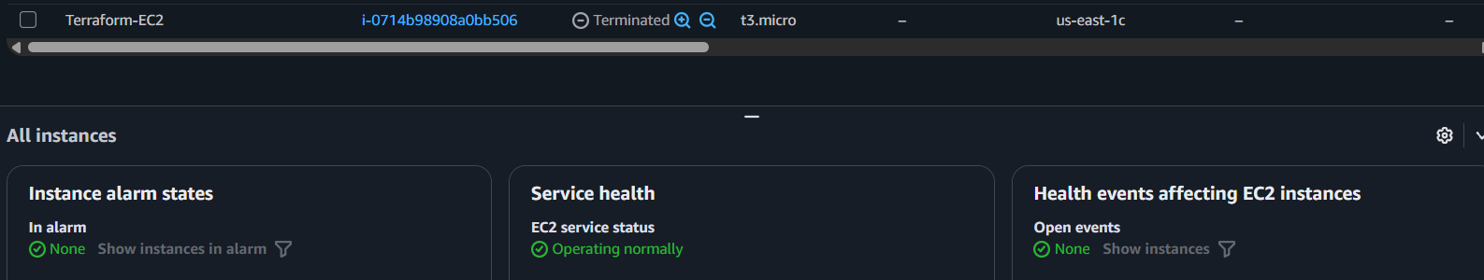

2.Write a Terraform script to provision an S3 bucket.
1. Create a new folder
For example:
C:\Users\sriva\Desktop\Terraform-provider\S3-bucket
Open PowerShell there:
cd C:\Users\sriva\Desktop\Terraform-provider\S3-bucket

2. Create main.tf
Put this code inside:
Important
S3 bucket names must be globally unique.
terraform {
required_providers {
aws = {
source = "hashicorp/aws"
version = "~> 6.0"
}
}
}

provider "aws" {
region = var.region
}

resource "aws_s3_bucket" "mybucket" {
bucket = var.bucket_name

tags = {
Name = var.bucket_tag
}
}

Create variable.tf
variable "region" {
default = "us-east-1"
type = string
}

variable "bucket_name" {
default = "my-terraform-bucket"
type = string
}

variable "bucket_tag" {
default = "Terraform-S3"
type = string
}
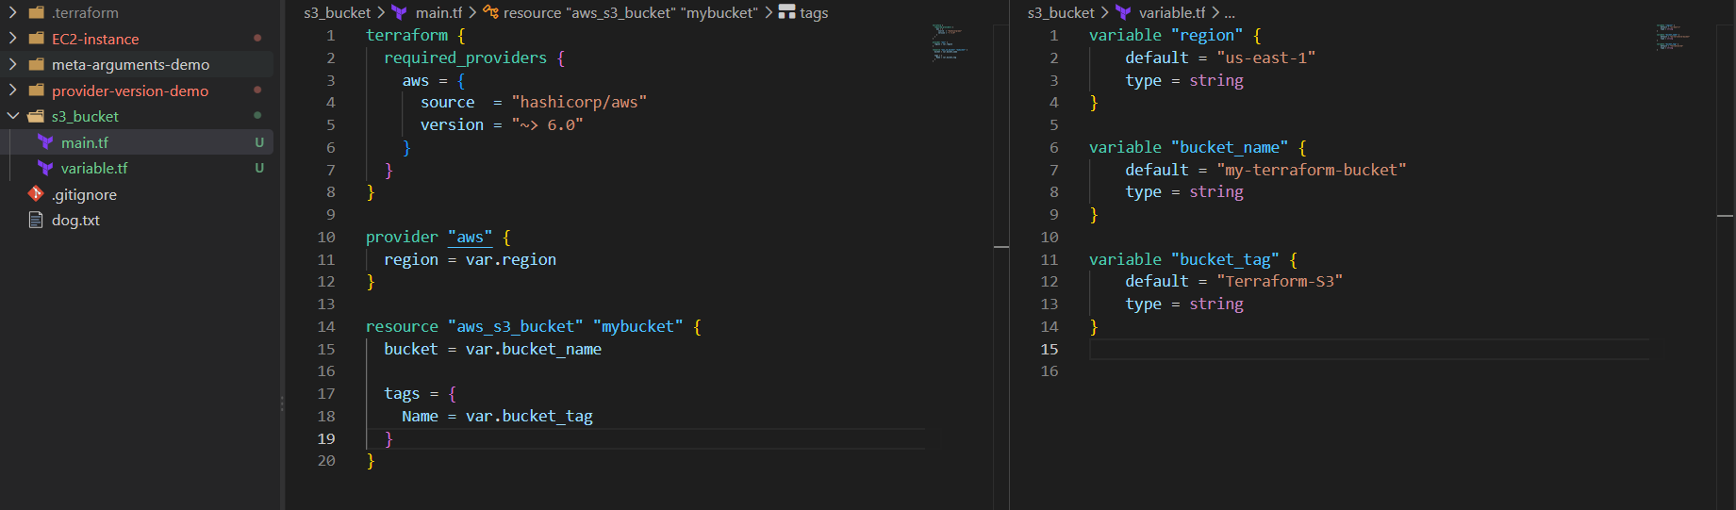

3. Run Terraform commands
terraform init
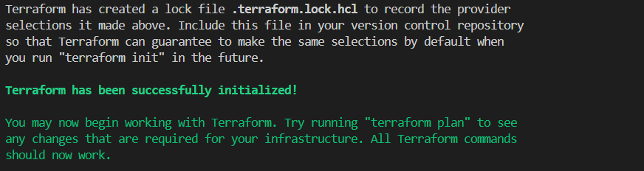
Then:
terraform validate
Then:
terraform plan
You should see:
Plan: 1 to add, 0 to change, 0 to destroy.
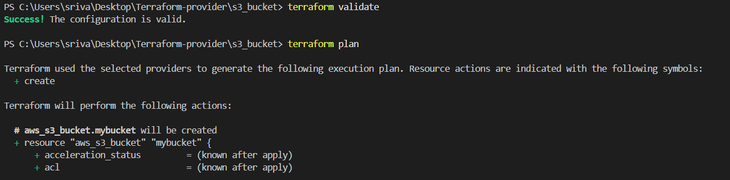
Then:
terraform apply
Enter:
Yes
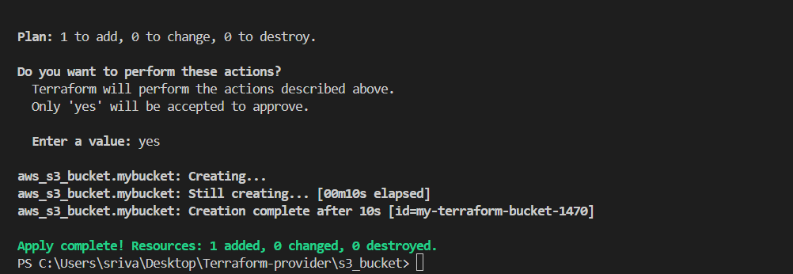

4. Verify S3 bucket
Run:
aws s3 ls
You should see your bucket.
Or check:
AWS Console → S3
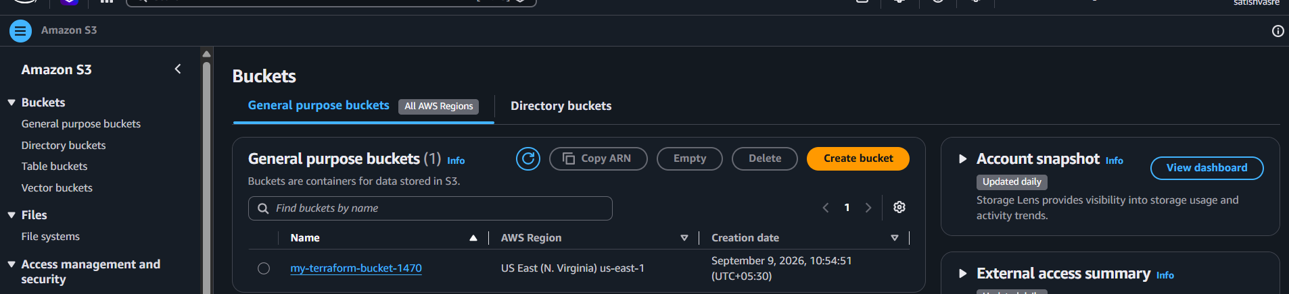

3.Provision 3 EC2 instances in 3 different regions

Step 1: Create files
3-ec2-regions/
├── main.tf
└── variables.tf

Step 2: main.tf
provider "aws" {
alias = "mumbai"
region = var.mumbai_region
}

provider "aws" {
alias = "virginia"
region = var.virginia_region
}

resource "aws_instance" "mumbai" {
provider = aws.mumbai
ami = var.mumbai_ami
instance_type = "t3.micro"

tags = {
Name = "EC2-Mumbai"
}
}

resource "aws_instance" "virginia" {
provider = aws.virginia
ami = var.virginia_ami
instance_type = "t3.micro"

tags = {
Name = "EC2-Virginia"
}
}
Step 3: variables.tf

variable "mumbai_region" {
default = "ap-south-1"
}

variable "virginia_region" {
default = "us-east-1"
}

variable "mumbai_ami" {
default = "AMI-MUMBAI-ID"
}

variable "virginia_ami" {
default = "AMI-VIRGINIA-ID"
}
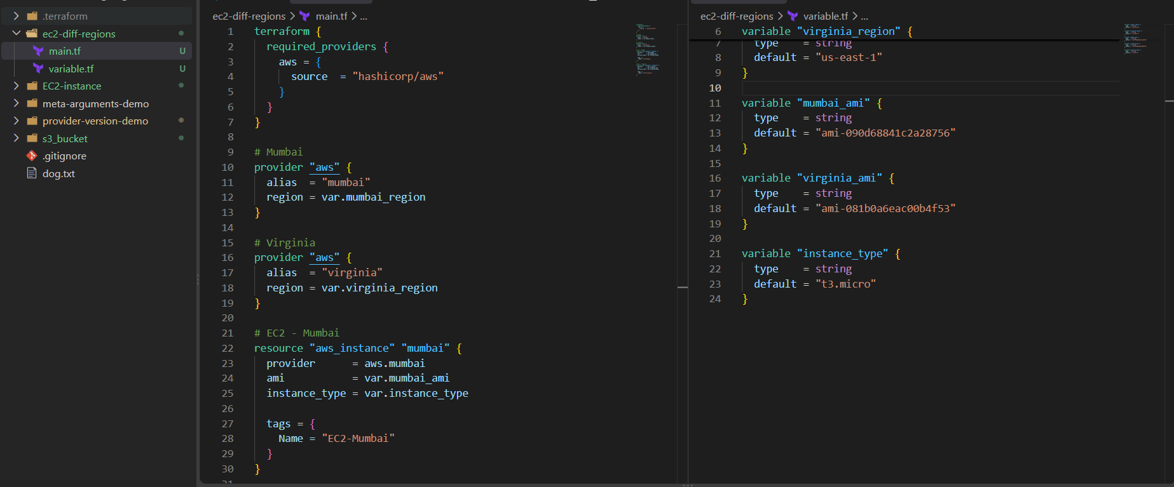
Step 5: Run
terraform init
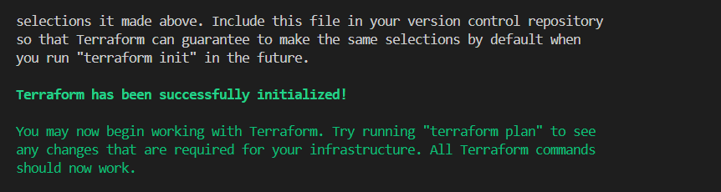
terraform plan
terraform apply
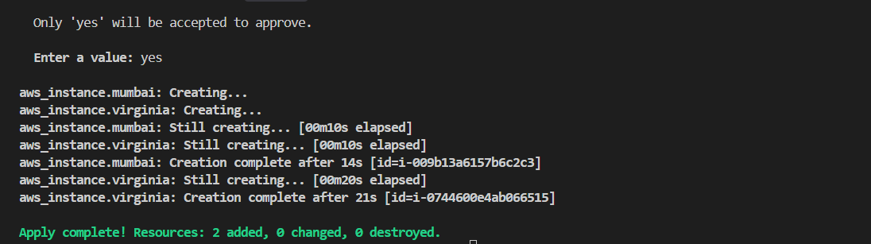
Key point
Different regions → different provider aliases → different AMI IDs.
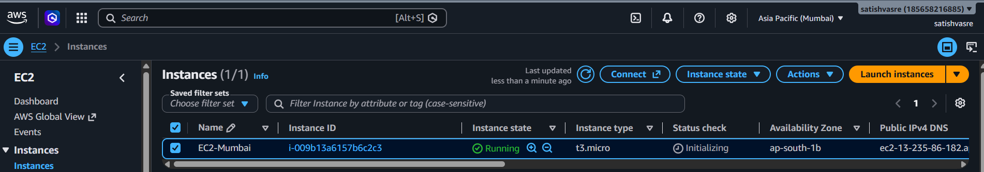
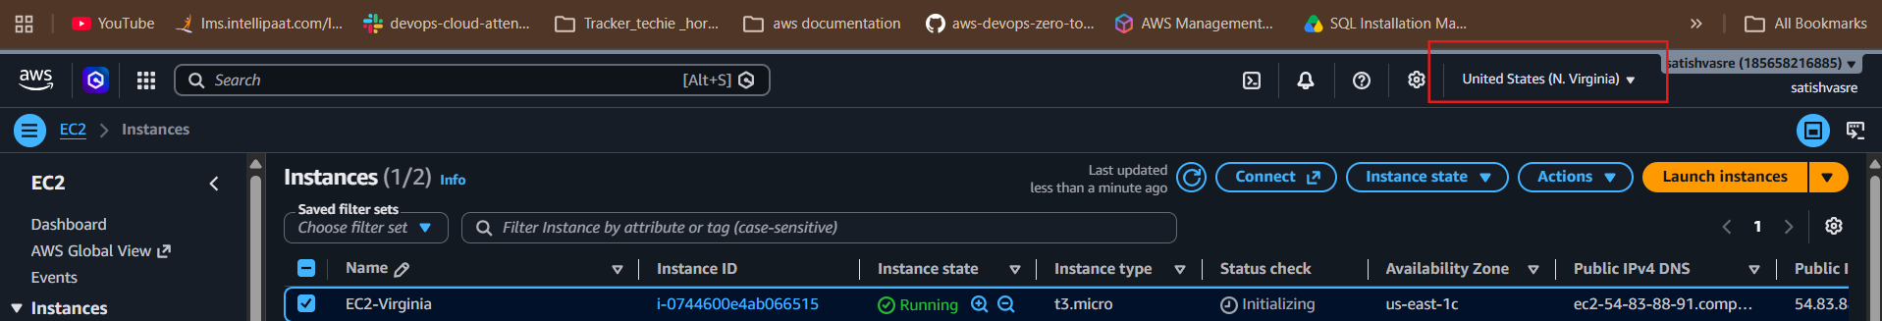

terraform destroy
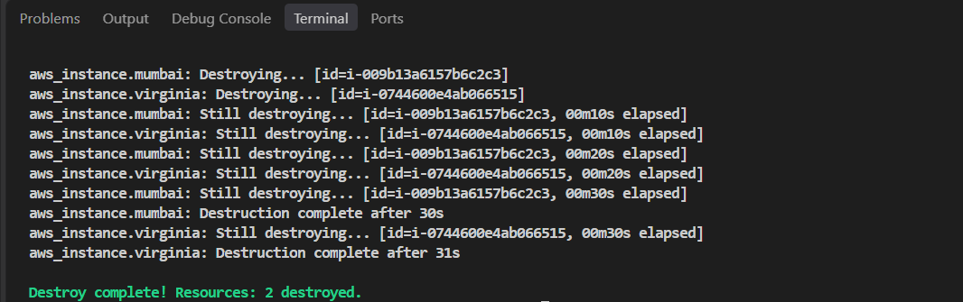

4. Provision multiple EC2 instances using count and for_each
Step 1: Create main.tf
Using count:
resource "aws_instance" "web_count" {
count = 2
ami = var.ami
instance_type = "t3.micro"

tags = {
Name = "EC2-${count.index + 1}"
}
}
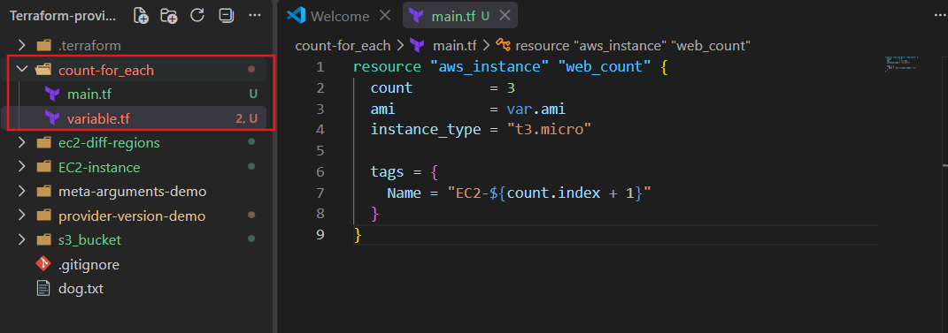

Using for_each:
resource "aws_instance" "web_each" {
for_each = toset(["dev", "test"])
ami = var.ami
instance_type = "t3.micro"

tags = {
Name = "EC2-${each.key}"
}
}
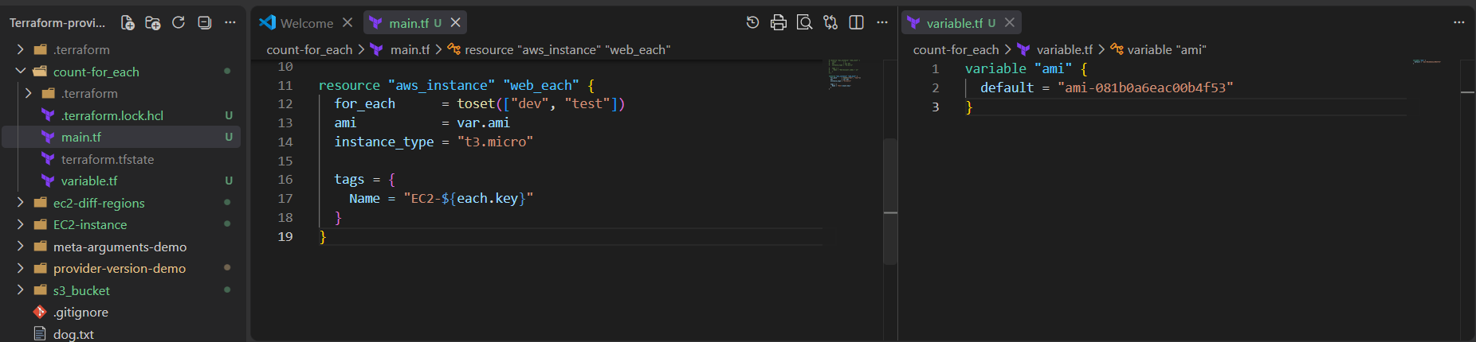
Step 2: variables.tf
variable "ami" {
default = "YOUR_AMI_ID"
}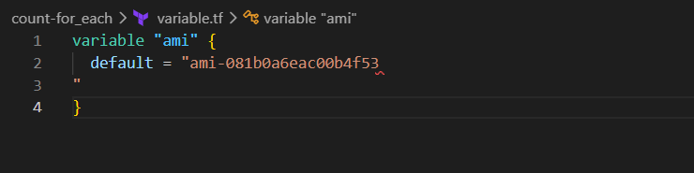
Step 3: Run
terraform init
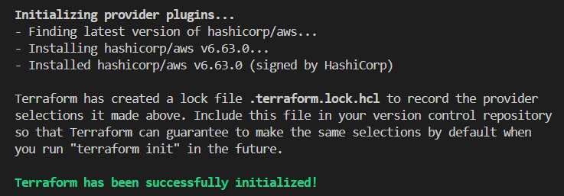
terraform plan
terraform apply 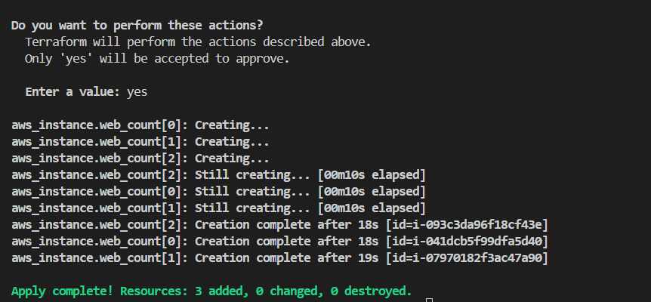
Difference
count → creates instances using numbers/index
for_each → creates instances using unique names/keys
For example:
count → EC2-1, EC2-2
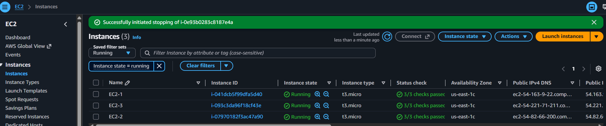
for_each → EC2-dev, EC2-test
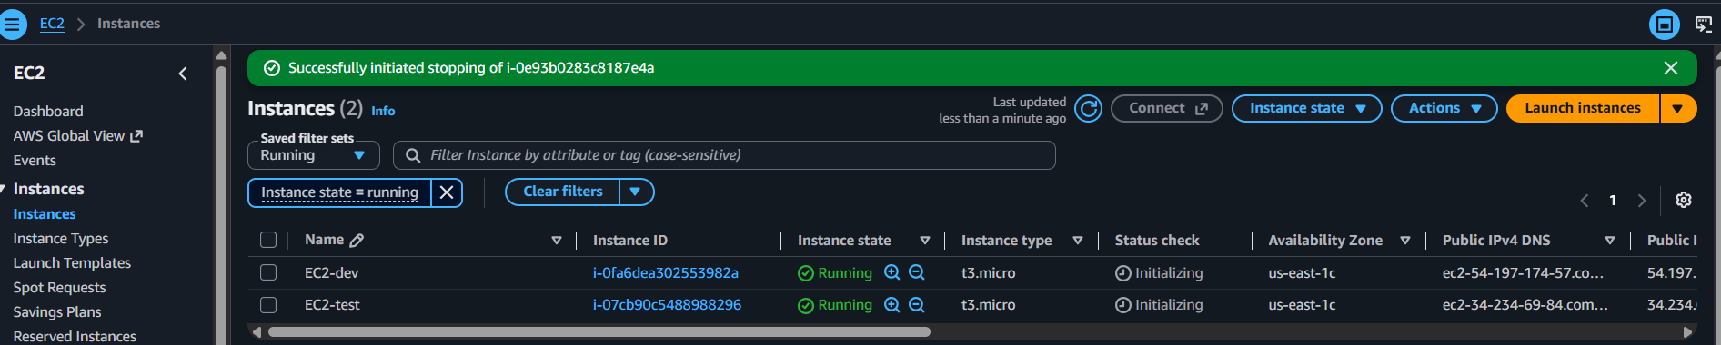

5.Write a Terraform script to provision an EC2 instance using a module.
Step 1: Create folder structure
ec2-module/
├── main.tf
├── variables.tf
└── modules/
└── ec2/
├── main.tf
└── variables.tf
Step 2: modules/ec2/main.tf
resource "aws_instance" "this" {
ami = var.ami
instance_type = var.instance_type

tags = {
Name = var.name
}
}
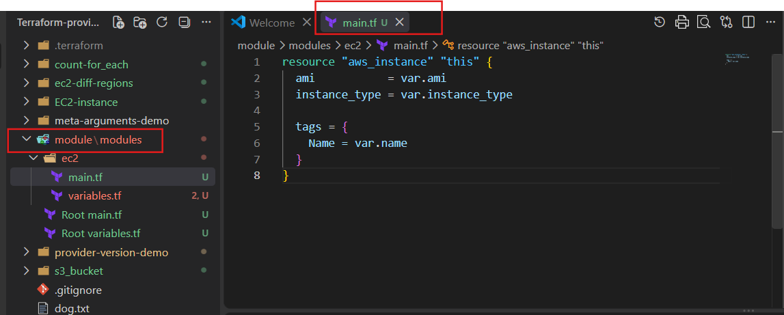

Step 3: modules/ec2/variables.tf
variable "ami" {}

variable "instance_type" {}

variable "name" {}
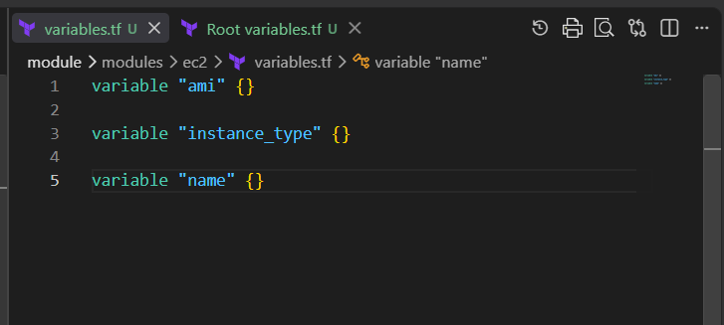
Step 4: Root variables.tf
variable "ami" {
default = "YOUR_AMI_ID"
}

variable "instance_type" {
default = "t3.micro"
}

variable "name" {
default = "Terraform-Module-EC2"
}

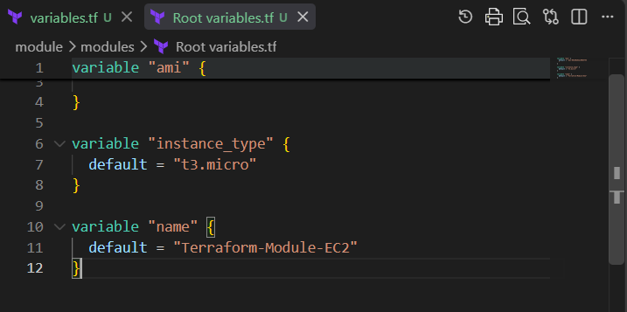
Step 5: Root main.tf
provider "aws" {
region = "us-east-1"
}

module "ec2" {
source = "./modules/ec2"
ami = var.ami
instance_type = var.instance_type
name = var.name
} 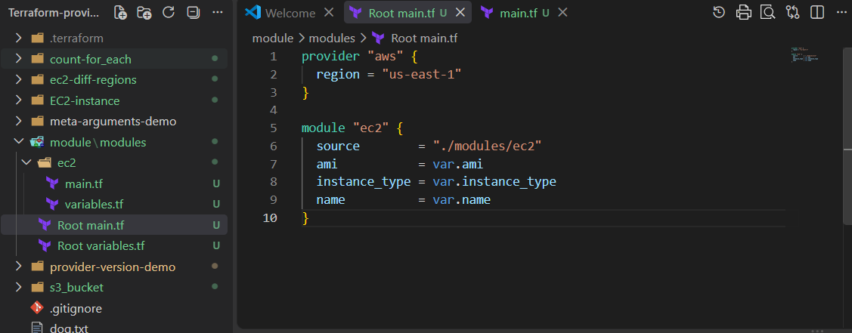

Step 6: Run
terraform init 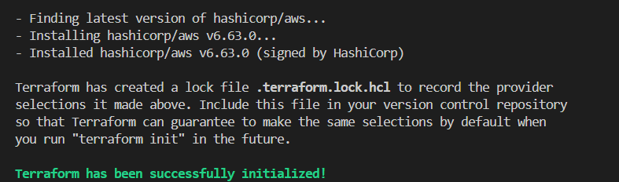
terraform plan
terraform apply
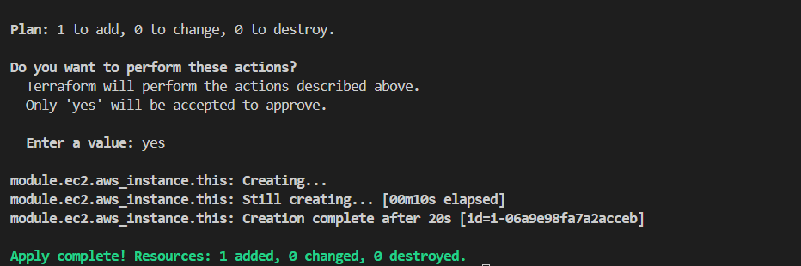
To remove it:
terraform destroy
Simple concept:
main.tf → calls the module → module creates the EC2 instance.
Check Terraform state
Run:
terraform state list
terraform state show module.ec2.aws_instance.this
You should see details such as:
id = i-xxxxxxxxxxxxxxxxx
instance_type = t3.micro
ami = ami-081b0a6eac00b4f53 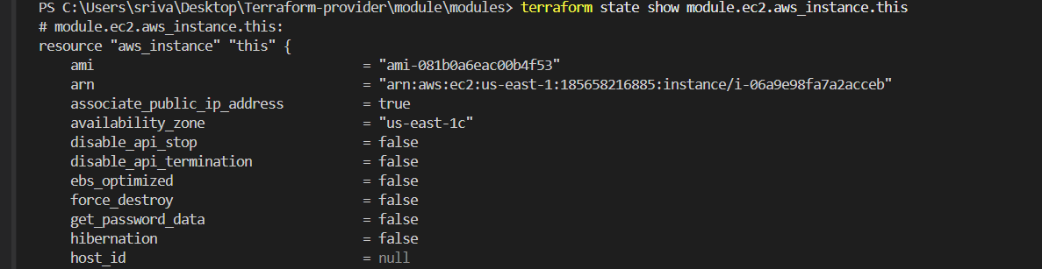

3. Verify in AWS Console
Go to:
AWS Console → EC2 → Instances → us-east-1 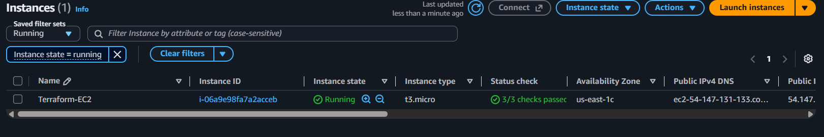

6. Write a Terraform script to provision an RDS database instance.
1. Create folder
Inside your Terraform practice directory:
rds-instance
├── main.tf
├── variables.tf
2. main.tf
provider "aws" {
region = "us-east-1"
}

resource "aws_db_instance" "mysql" {
allocated_storage = 20
engine = "mysql"
engine_version = "8.0"
instance_class = "db.t3.micro"
db_name = "mydb"

username = var.db_username
password = var.db_password

skip_final_snapshot = true
publicly_accessible = false

tags = {
Name = "Terraform-RDS"
}
} 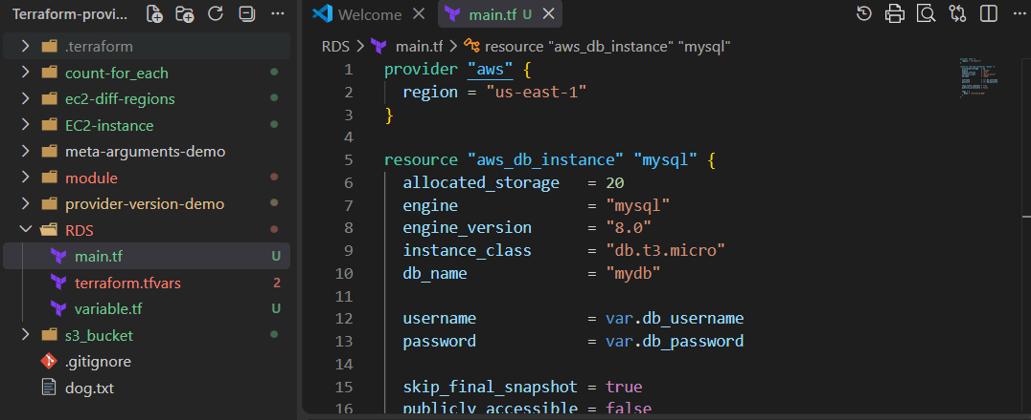
3. variables.tf
variable "db_username" {
type = string
sensitive = true
}

variable "db_password" {
type = string
sensitive = true
}
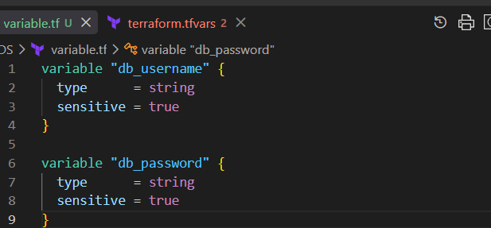

4. terraform.tfvars
Put your actual credentials here:
db_username = "admin"
db_password = "YourStrongPassword123!" 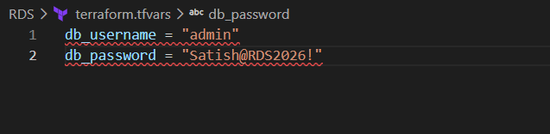
Then run:
terraform init 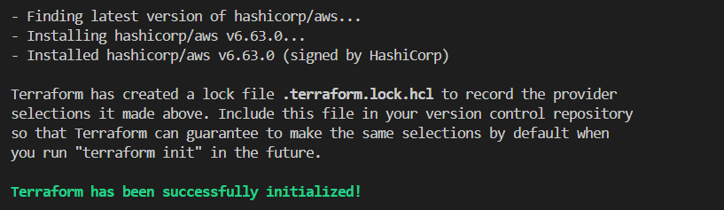
terraform validate
terraform plan
terraform apply
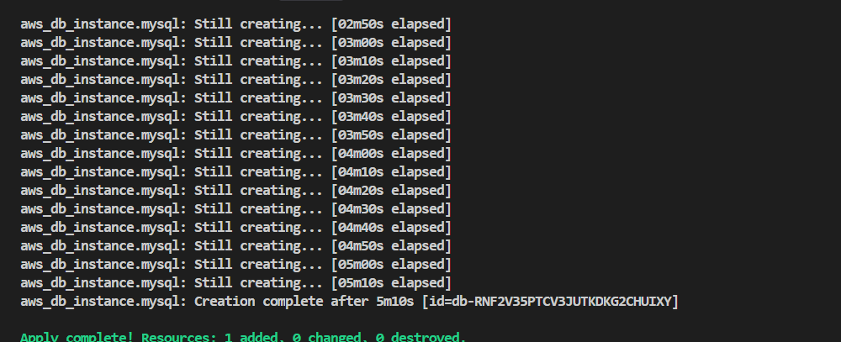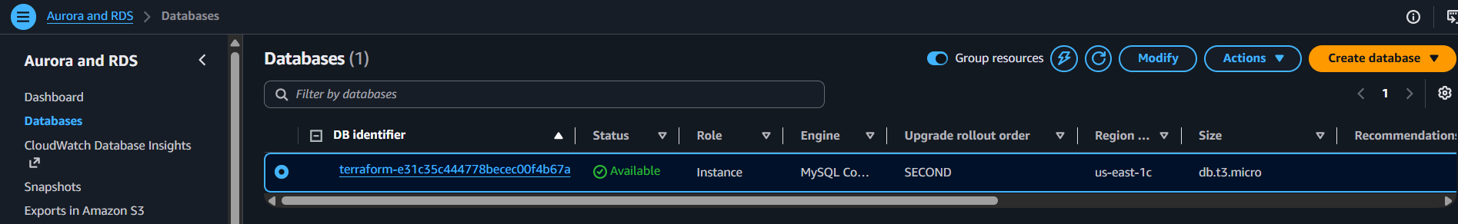

- What is the use of terraform import?
If a resource was created manually in AWS, Terraform does not automatically know about it.
terraform import connects that existing resource with Terraform's state file.
Important points:
- It is used for existing resources.
- It adds the resource information to the Terraform state.
- It does not create a new resource.
- It does not automatically generate the Terraform configuration.
- After importing, we write the required Terraform configuration and use terraform plan to check for differences.

Hands-on
Existing EC2 is:
- Name: terraform-server
- Instance ID: i-0e93b0283c8187e4a
You can use this EC2 to practice terraform import.
Step 1: Create main.tf
In your Terraform directory, create:
provider "aws" {
region = "us-east-1"
}

resource "aws_instance" "terraform_server" {
}

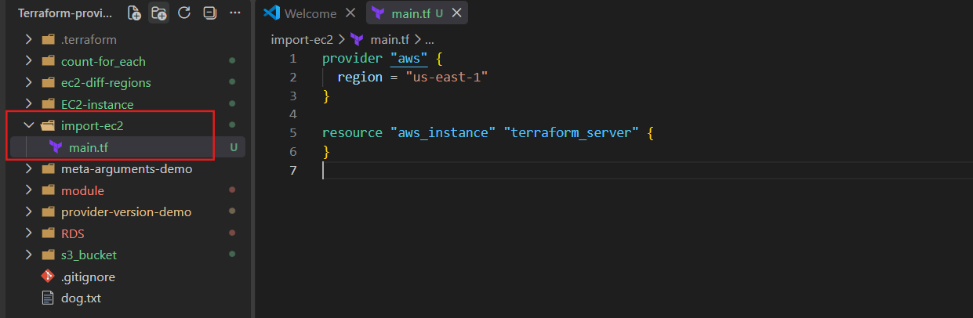
The resource block must exist before you run import.
Step 2: Initialize Terraform
terraform init 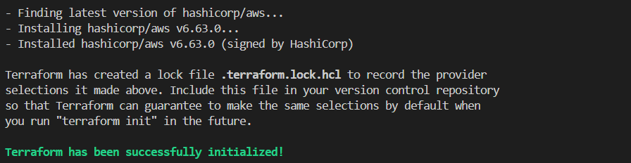
Step 3: Import your existing EC2
Run:
terraform import aws_instance.terraform_server i-0e93b0283c8187e4a
Here:
aws_instance.terraform_server
│ │
│ └── resource name in your .tf file
└── AWS resource type

i-0e93b0283c8187e4a
└── Existing EC2 Instance ID
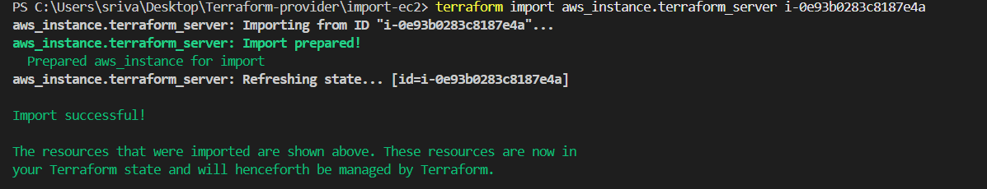
Step 4: Check the state
terraform state list
You should see:
aws_instance.terraform_server
Then:
terraform state show aws_instance.terraform_server
This will show details of your imported EC2. 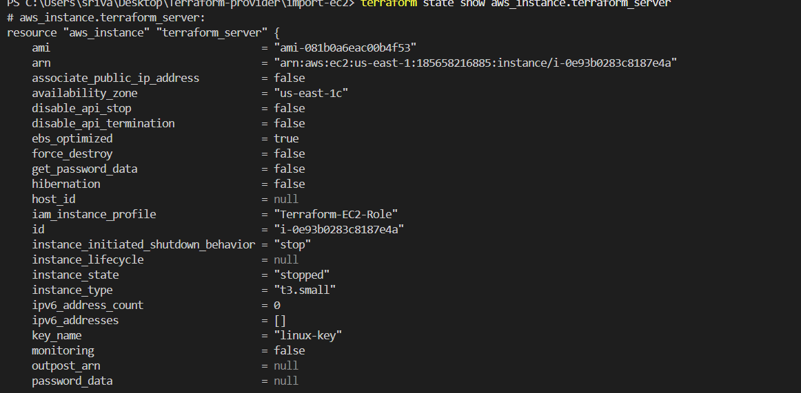
Step 5: Run plan
terraform plan
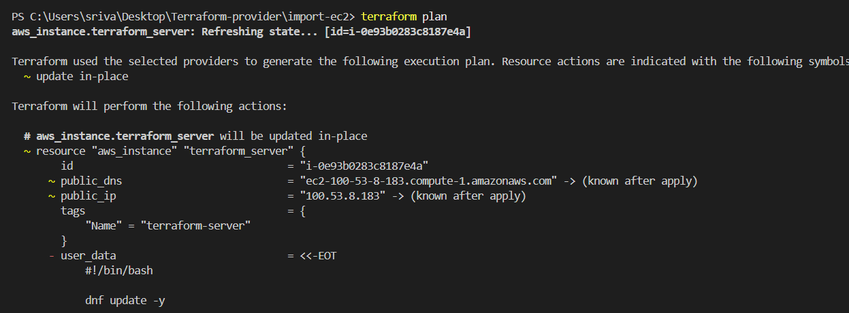
You will probably see changes because our main.tf currently doesn't contain the EC2 configuration.
Important: terraform import does not create the EC2. Your EC2 already exists. Import simply tells Terraform:
Existing EC2
↓
terraform import
↓
terraform.tfstate
↓
Terraform now knows about the EC2
After importing, we can also write the complete main.tf for your existing terraform-server so that terraform plan shows 0 changes.

- What is the use of terraform refresh?

Definition
Terraform refresh is used to update Terraform's state information with the current information of the real infrastructure.
In simple words:
Terraform checks what is actually present in AWS and updates its state information accordingly.

Why do we use Terraform Refresh?
We use refresh mainly when there is a difference between Terraform's state and the actual infrastructure in AWS.
For example:
Initially:
Terraform State → EC2 t3.micro
AWS → EC2 t3.micro
Someone manually changes something in AWS:
Terraform State → EC2 t3.micro
AWS → EC2 t3.small
Now Terraform's state information is not completely up to date.
Refresh allows Terraform to check AWS and update its state with the latest information.
Main purpose
To synchronize Terraform state with the actual infrastructure.

Terraform Refresh — Short Hands-on
- Create a folder:
mkdir refresh-demo
cd refresh-demo
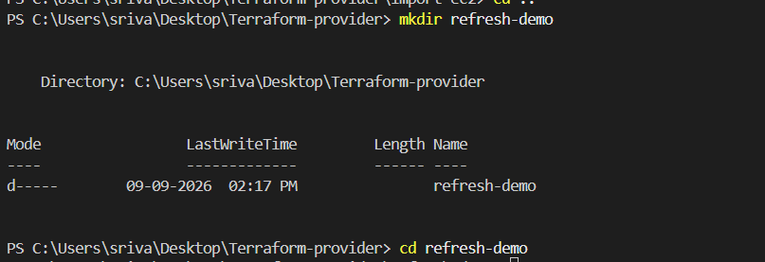
- Create main.tf with an EC2 resource.
- Initialize:
terraform init 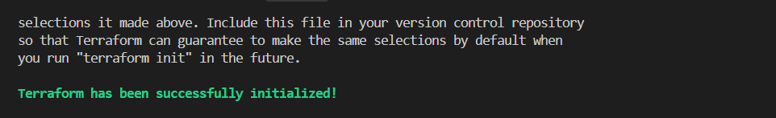
- Create the EC2:
terraform apply 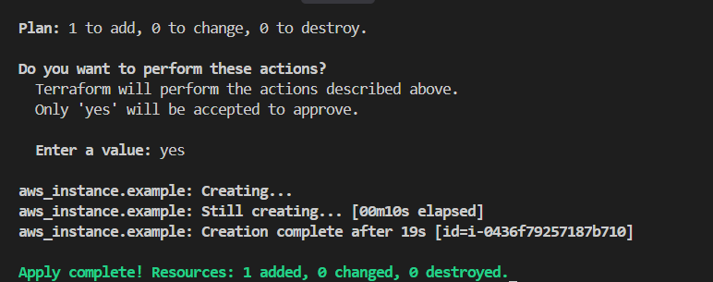
- Check Terraform state:
terraform state list
- Manually change something in the EC2 from AWS Console, such as a Name tag.
Changed refresh-demo to refresh-deom-modified

- Refresh the state:
terraform plan -refresh-only 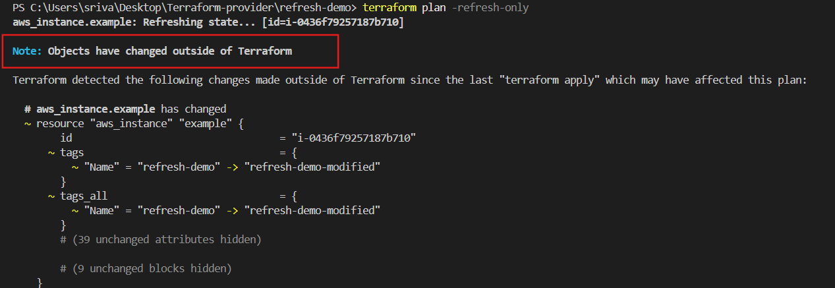
- To update the state:
terraform apply -refresh-only 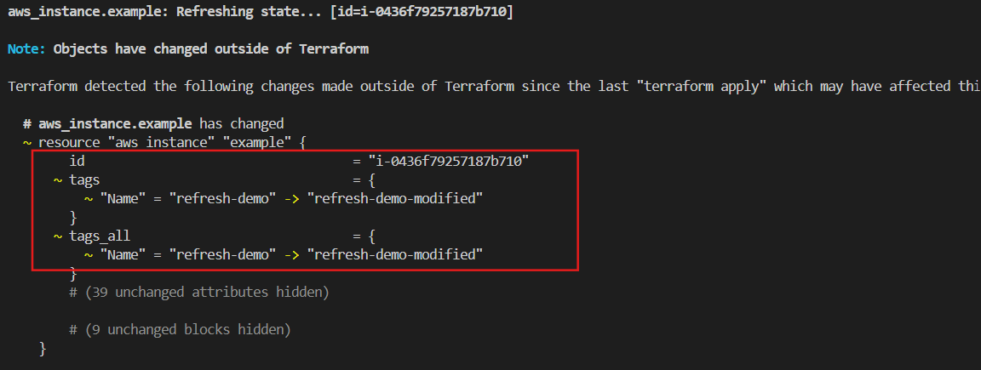
- Verify:
terraform state show aws_instance.example 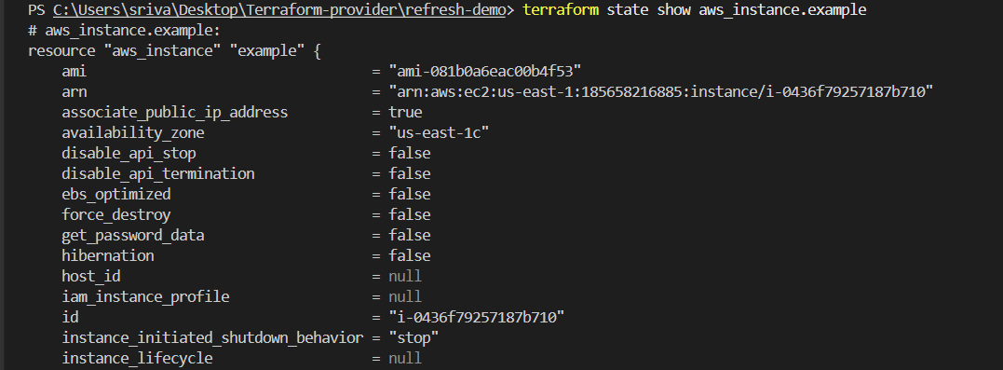
Remember:
AWS → Refresh → Terraform State
It detects changes in the real AWS infrastructure and updates Terraform's understanding of it.

9. What is the use of Terraform workspaces?
Definition:
Terraform workspaces allow you to manage multiple separate environments using the same Terraform configuration.
Why?
To maintain separate environments such as:
- dev
- test
- prod
Each workspace has its own Terraform state.
How?
Terraform uses the same .tf files, but each workspace maintains a separate state, so resources in one workspace are isolated from another.

hands-on
- Check current workspace:
terraform workspace show 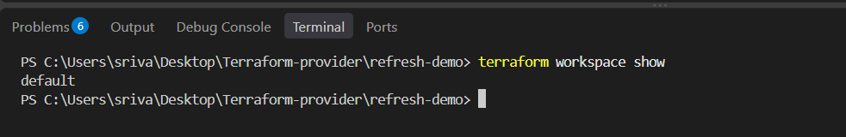
- List workspaces:
terraform workspace list

- Create Dev:
terraform workspace new dev 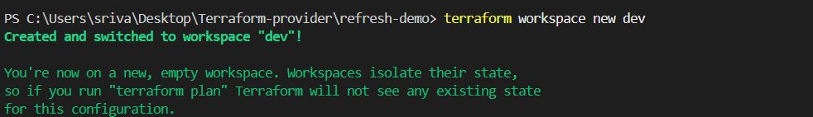
- Create Prod:
terraform workspace new prod 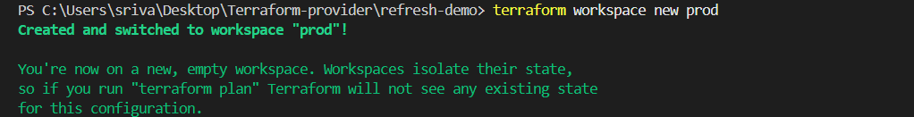
- Switch to Dev:
terraform workspace select dev
- Switch to Prod:
terraform workspace select prod
- Verify:
terraform workspace show
Remember
Same Terraform code
↓
┌────┴────┐
dev prod
↓ ↓
State 1 State 2
Interview one-liner:
Terraform workspaces are used to manage multiple environments with the same Terraform configuration while maintaining separate state files.
10.What is the use of Terraform backend?
Terraform Backend
Definition
Terraform backend defines where Terraform stores its state file (terraform.tfstate).
Why?
- To store the state safely.
- To allow multiple team members to work on the same Terraform project.
- To avoid keeping the state file only on your local machine.
- Common backend: S3.
How?
Instead of storing terraform.tfstate locally, Terraform can store it in a remote backend such as Amazon S3.
hands-on
Since you're currently in:
C:\Users\sriva\Desktop\Terraform-provider\refresh-demo
For practice:
- Create an S3 bucket in AWS.
- Add an S3 backend configuration in main.tf.
- Run:
terraform init
- Run:
terraform apply 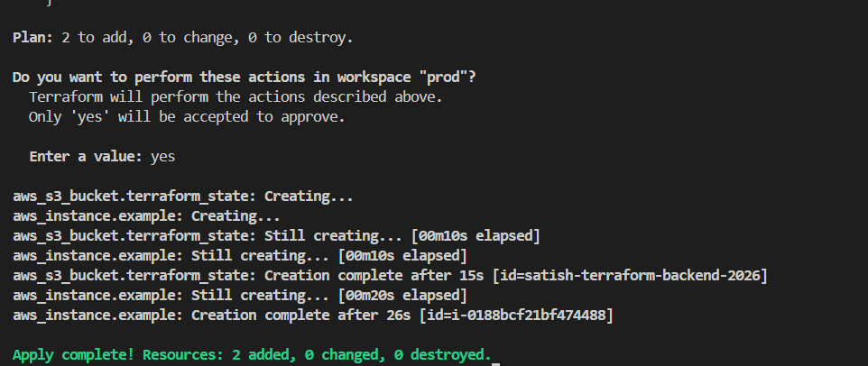

- Add this to main.tf:
terraform {
backend "s3" {
bucket = "satish-terraform-backend-2026"
key = "terraform.tfstate"
region = "us-east-1"
}
} 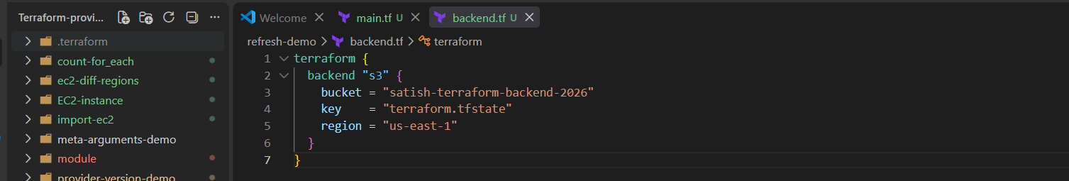
Then run:
terraform init
Terraform should ask to migrate the existing state to S3.
Type:
Yes
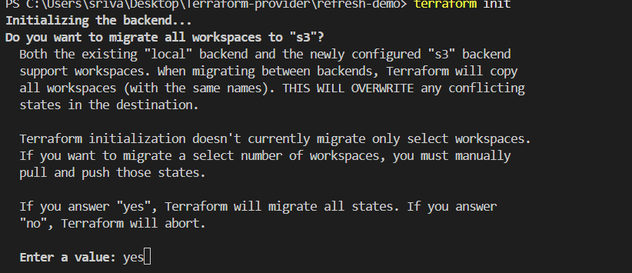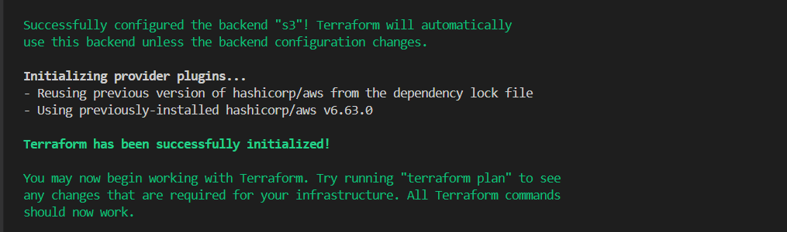

- What is the use of Terraform output block?

Definition
Terraform output block is used to display important information after terraform apply, such as an EC2 public IP, instance ID, DNS name, etc.
Why?
Instead of manually checking AWS Console, Terraform can show the required value directly in the terminal.
How?
You define an output block and tell Terraform which resource value you want to display.

Hands -on
Step 1: Open main.tf
Add this at the bottom:
output "instance_public_ip" {
value = aws_instance.example.public_ip
} 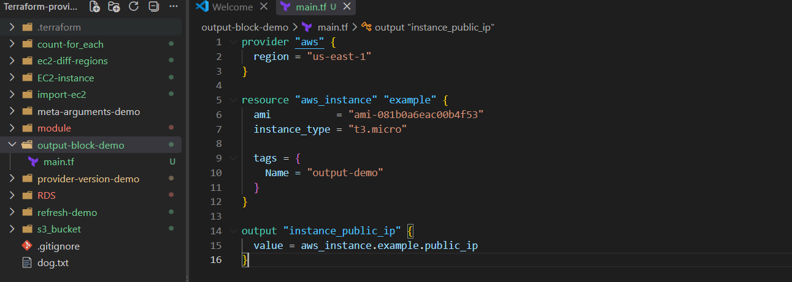
Step 2: Run
terraform plan 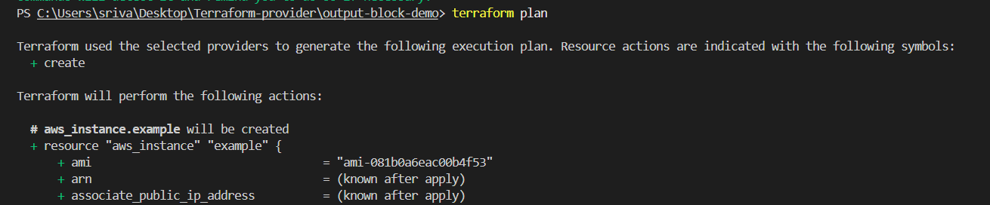
Then:
terraform apply 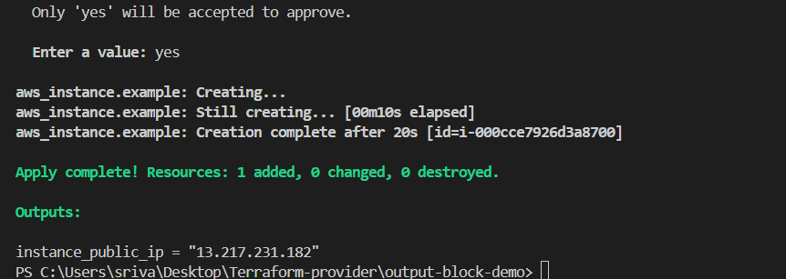

terraform output
terraform output instance_public_ip
Remember
resource → creates EC2
output → displays EC2 information

12. What is the use of Terraform data sources?
Definition
A Terraform data source is used to read/get existing information from AWS or another provider without creating a new resource.
Purpose / Why?
We use data sources when a resource already exists and we want to use its information in our Terraform configuration.
For example:
- Get an existing AMI ID
- Get an existing VPC
- Get an existing subnet
- Get existing security group information

Hands-on
Create main.tf:
provider "aws" {
region = "us-east-1"
}

data "aws_ami" "amazon_linux" {
most_recent = true

owners = ["amazon"]

filter {
name = "name"
values = ["al2023-ami-*-x86_64"]
}
}

output "ami_id" {
value = data.aws_ami.amazon_linux.id
}
Run: 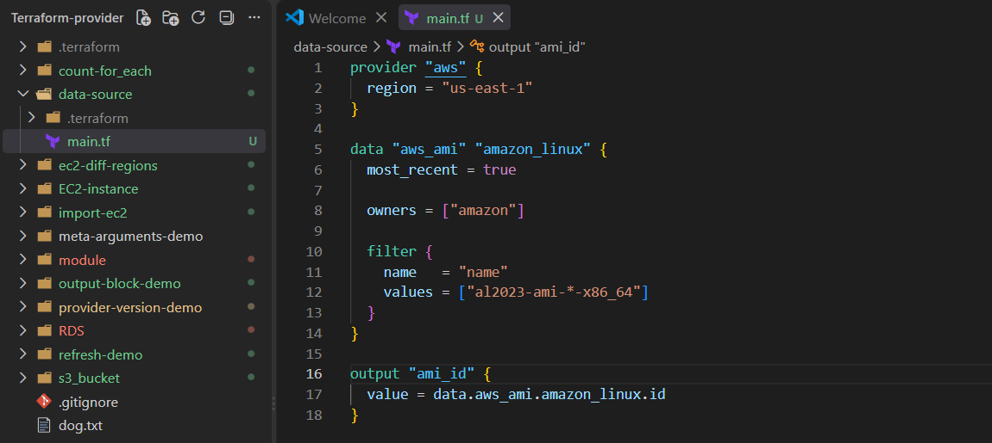
terraform init
Then: 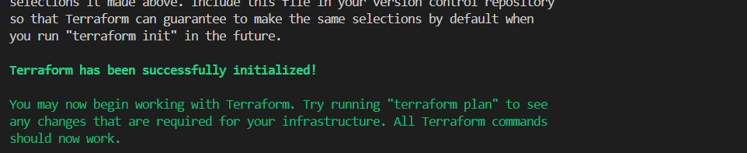
terraform plan
Then:
terraform apply 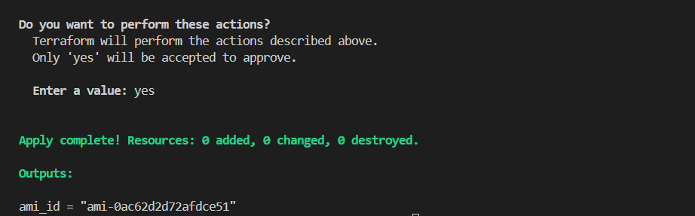
You should get:
Outputs:

ami_id = "ami-xxxxxxxxxxxxxxxxx"
Here Terraform didn't create an AMI.
It simply:
AWS
↓
Find existing Amazon Linux AMI
↓
Terraform data source
↓
ami_id

13.What is the use of Terraform provisioners?
Definition
Terraform provisioners are used to run scripts or commands on a resource after it is created or before it is destroyed.
Purpose / Why?
They are mainly used when you need to perform some additional setup that Terraform resources cannot directly handle.
For example:
- Install software
- Copy files
- Run shell commands
- Execute configuration scripts
How?
Terraform creates EC2
↓
Provisioner runs command
↓
Software/configuration is done
Types
1. local-exec
Runs a command on the machine where Terraform is running.
2. remote-exec
Runs commands inside the remote resource, such as an EC2 instance.

hands-on:
Create a separate folder, for example:
Terraform-provider/
└── provisioner-demo/
└── main.tf

provisioner configuration in main.tf.
provider "aws" {
region = "us-east-1"
}

resource "aws_instance" "example" {
ami = "ami-081b0a6eac00b4f53"
instance_type = "t3.micro"

tags = {
Name = "provisioner-demo"
}

provisioner "local-exec" {
command = "echo EC2 instance created"
}
}
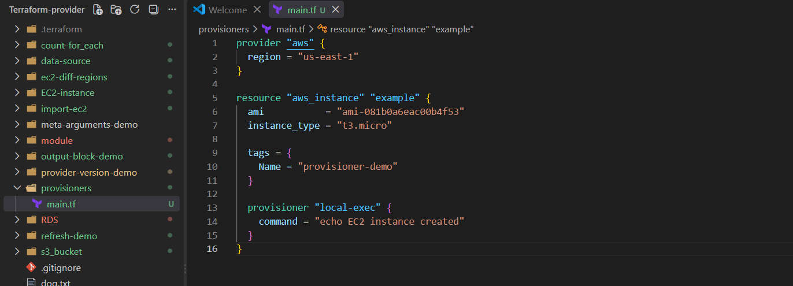

Then run:
terraform init 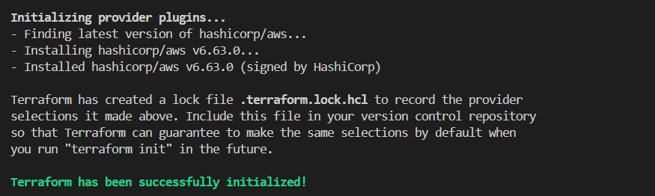
terraform plan
terraform apply 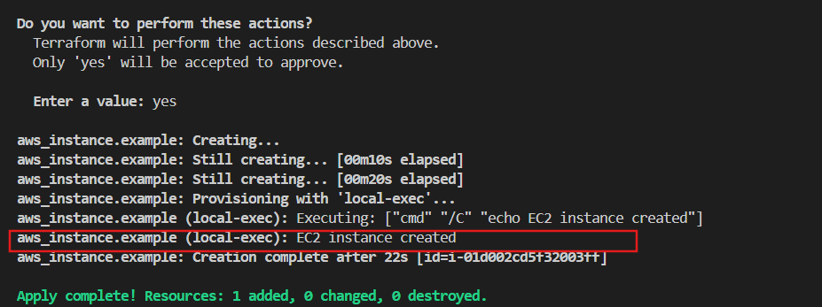
After the EC2 is created, you should see:
EC2 instance created
Verify from Terraform state
terraform state list

14.What is Terraform statefile locking and why is it important?
Definition
State file locking prevents multiple people or Terraform processes from modifying the same Terraform state file at the same time.
Purpose / Why?
It prevents:
- State file corruption
- Conflicting Terraform changes
- Two users running terraform apply simultaneously
How?
User A → terraform apply
↓
State is LOCKED 🔒
↓
User B → terraform apply
↓
❌ Cannot modify state
After User A finishes:
State → UNLOCKED 🔓
Important point
State locking is mainly useful with remote backends when multiple people work on the same infrastructure.

For example:
Jenkins ──┐
├──→ Remote Terraform State 🔒
Developer ─┘

Hands-on: State Locking
1. Create a separate folder
C:\Users\sriva\Desktop\Terraform-provider\state-locking-demo
2. Inside it create
main.tf
3. Put this in main.tf:
terraform {
backend "s3" {
bucket = "satish-terraform-backend-2026"
key = "state-locking-demo/terraform.tfstate"
region = "us-east-1"
use_lockfile = true
}
}

provider "aws" {
region = "us-east-1"
}

resource "aws_s3_bucket" "demo" {
bucket = "satish-state-locking-demo-2026"
} 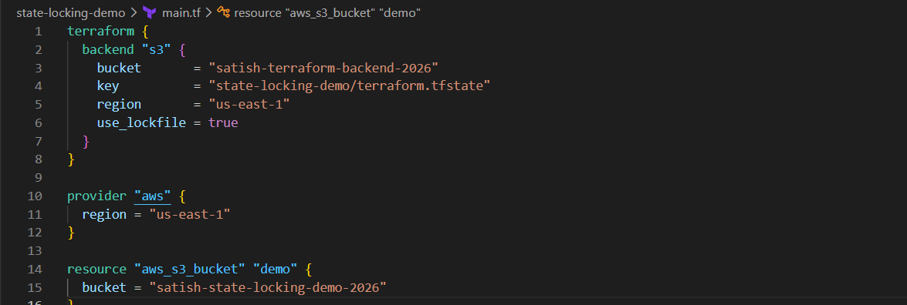
4. Run
cd C:\Users\sriva\Desktop\Terraform-provider\state-locking-demo
terraform init 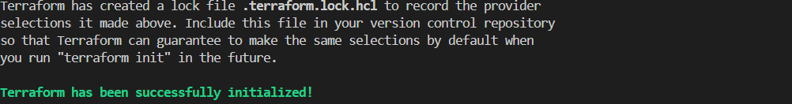
terraform apply 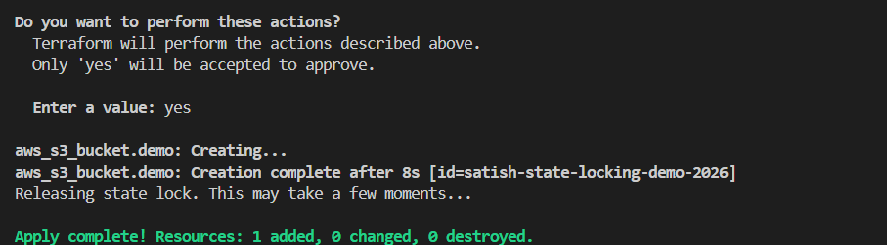

15. What is the use of Terraform Dynamic Block?

1. Definition
A Terraform dynamic block is used to dynamically create multiple nested blocks within a resource by iterating over a list, set, or map.
Simple definition:
A dynamic block allows Terraform to create multiple nested configuration blocks automatically instead of writing each block manually.

2. Why do we use Dynamic Block?
We use dynamic blocks when we have multiple similar nested blocks and don't want to write them one by one.
For example, a security group may need:
Port 80
Port 443
Port 8080
Port 22
3. Where do we use Dynamic Blocks?
Dynamic blocks are mainly used when a resource contains repeatable nested blocks.
Common examples:
- AWS Security Group → multiple ingress rules
- AWS Security Group → multiple egress rules
- AWS ALB → multiple listener rules
- AWS IAM policies → repeated statement-type structures in supported schemas
- AWS Route53 → multiple routing/record-related nested structures
- Other Terraform resources that have repeatable nested blocks

Hands-on
Create:
C:\Users\sriva\Desktop\Terraform-provider\dynamic-block-demo
Inside:
dynamic-block-demo
└── main.tf

main.tf
provider "aws" {
region = "us-east-1"
}

variable "ports" {
default = [80, 443, 8080]
}

resource "aws_security_group" "demo" {
name = "dynamic-demo"

dynamic "ingress" {
for_each = var.ports

content {
from_port = ingress.value
to_port = ingress.value
protocol = "tcp"
cidr_blocks = ["0.0.0.0/0"]
}
}

egress {
from_port = 0
to_port = 0
protocol = "-1"
cidr_blocks = ["0.0.0.0/0"]
}
} 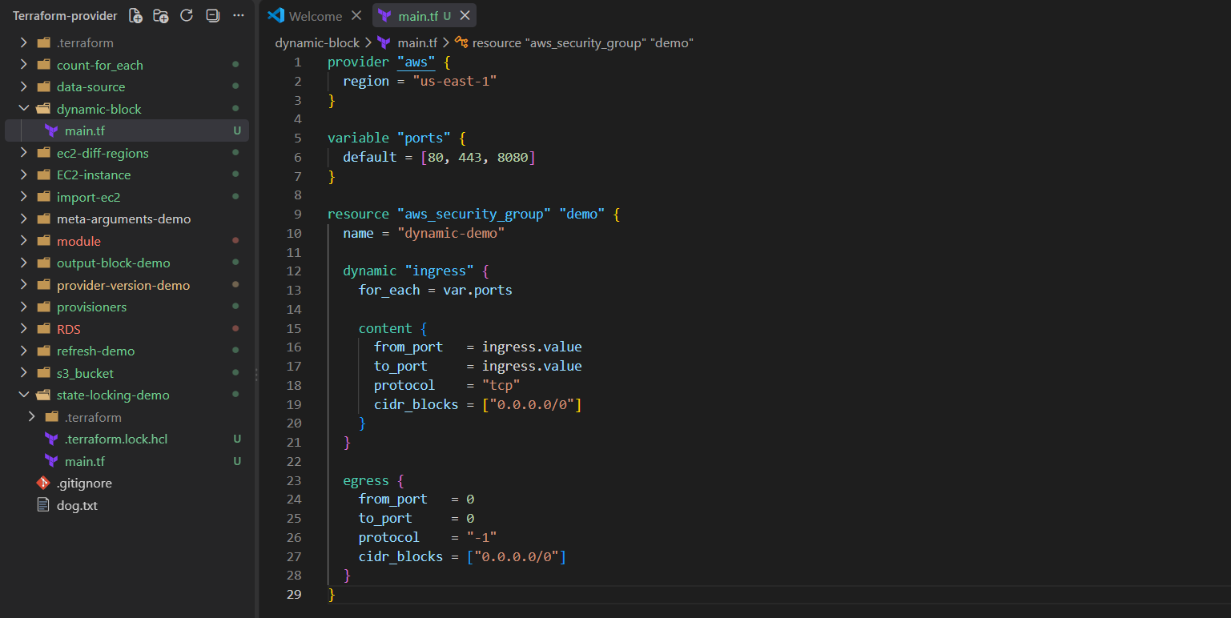
Run
cd C:\Users\sriva\Desktop\Terraform-provider\dynamic-block-demo
terraform init 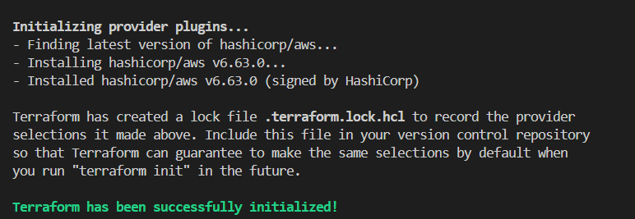
terraform plan
terraform apply 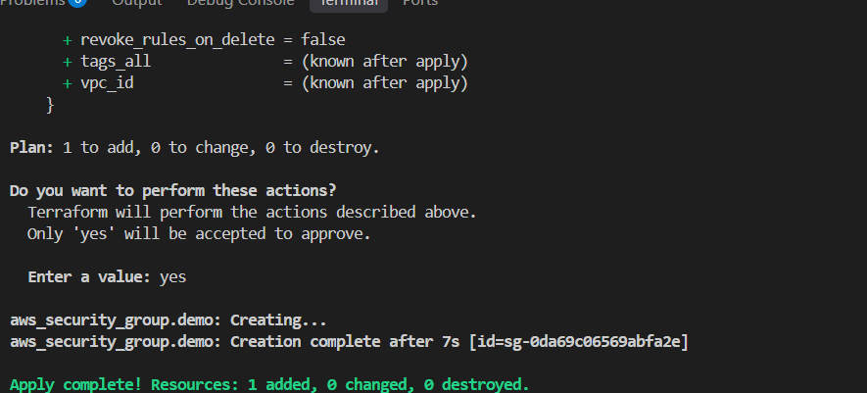
Verify
terraform state show aws_security_group.demo 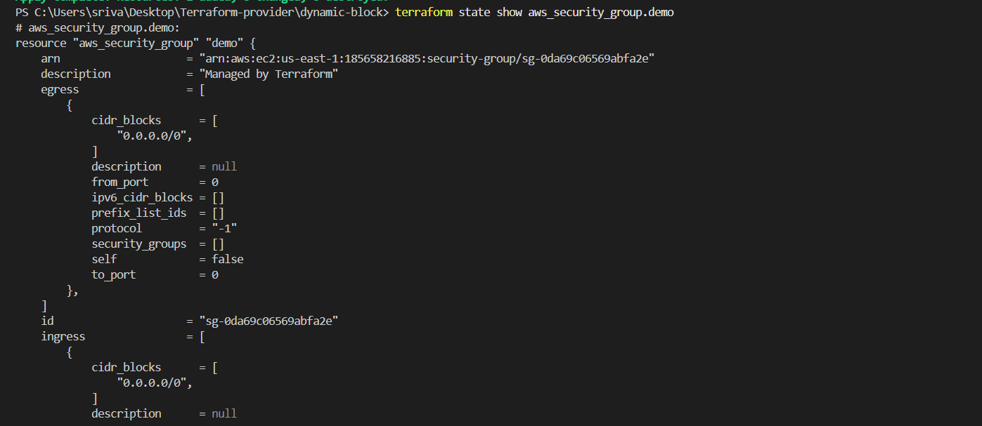

16. What is Terraform null_resource and when do we use it?
1. Definition
A null_resource is a Terraform resource that does not create any actual infrastructure.
It is mainly used as a placeholder to run provisioners or trigger actions based on Terraform changes.
Simple definition: null_resource is used when we need Terraform to perform an action but there is no actual infrastructure resource to create.

2. Why do we use it?
We use null_resource when we want to:
- Run a shell/PowerShell command
- Run a script
- Execute some custom action
- Run something when a particular value changes
- Connect Terraform with external scripts or commands
For example:
Terraform
↓
null_resource
↓
Run script/command
3. Where do we use it?
Common examples:
- Run a script after an EC2 instance is created
- Run configuration commands
- Trigger an external deployment script
- Perform custom actions that Terraform doesn't have a native resource for
Important: null_resource is generally a last-resort approach. Prefer native Terraform resources, user_data/cloud-init, or configuration tools such as Ansible when possible.
Interview one-liner
null_resource is a Terraform resource that does not create infrastructure but can be used with provisioners and triggers to perform custom actions or commands.

Hands-on
Create:
C:\Users\sriva\Desktop\Terraform-provider\null-resource-demo
Inside:
null-resource-demo
└── main.tf
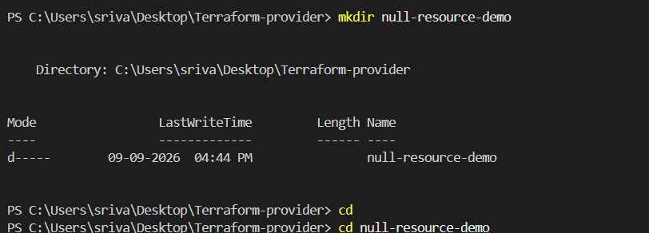
main.tf
provider "aws" {
region = "us-east-1"
}

resource "null_resource" "demo" {

provisioner "local-exec" {
command = "echo Hello from null_resource"
}
} 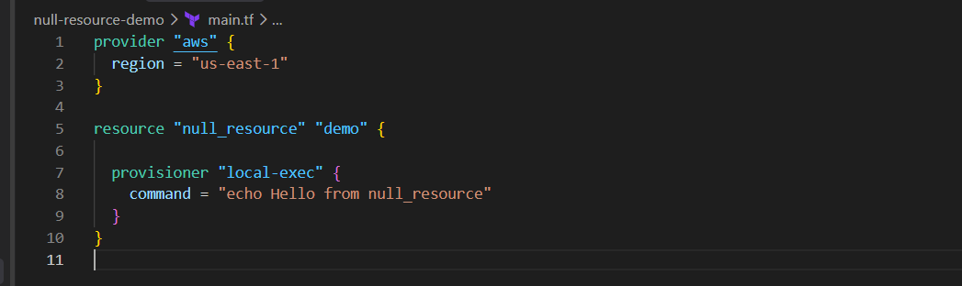
Run
cd C:\Users\sriva\Desktop\Terraform-provider\null-resource-demo

terraform init
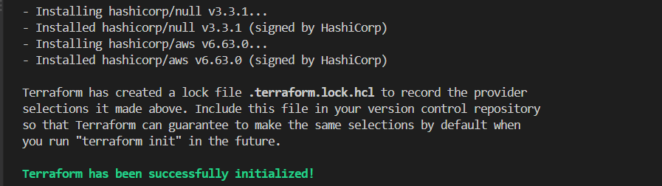
terraform plan
terraform apply
Enter:
yes 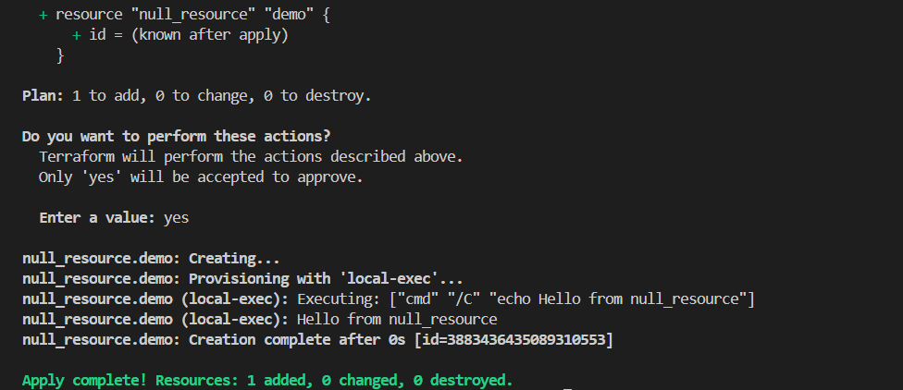
Verify
You should see:
Hello from null_resource
Then:
terraform state list

